TABLE OF CONTENT
EX NO | DATE | TITLE | PAGE NO
1
2
3
4
5
6
7
8
9

Ex No:1 Create a Web page for ABC INFOTECHT LTD, with Necessary image and marquee.
Date: 05.05.2024
Aim: To develop a webpage for ABC INFOTECHT LTD with Necessary tags.
CODE
<html>
<head>
<title>my abc infotech </title>
<h2><b><marquee bgcolor=red><font color="white" >abc infotech ltd</marquee></font></b></h2>
</head>
<body bgcolor=cyan><table border=1 bordercolor=blue align="center">
<tr><td>
<img src=ab.gif width=400 height=200>
</td></tr><center>
<table border=2 cellpadding=5 cellspacing=5>
<th>company profile</th>
<th>about company</th>
<th>employee</th>
</table>
<table border=1><th>
user login</table>
<table>
<tr><td>enter username</td>
<td><input type="text" name=user></td>
</tr><tr><td>enter password</td>
<td><input type="password" name=user></td>
</tr> <tr><td><center><input type=submit value=submit></center></tr>
</table>
</body>
</html>

OUTPUT
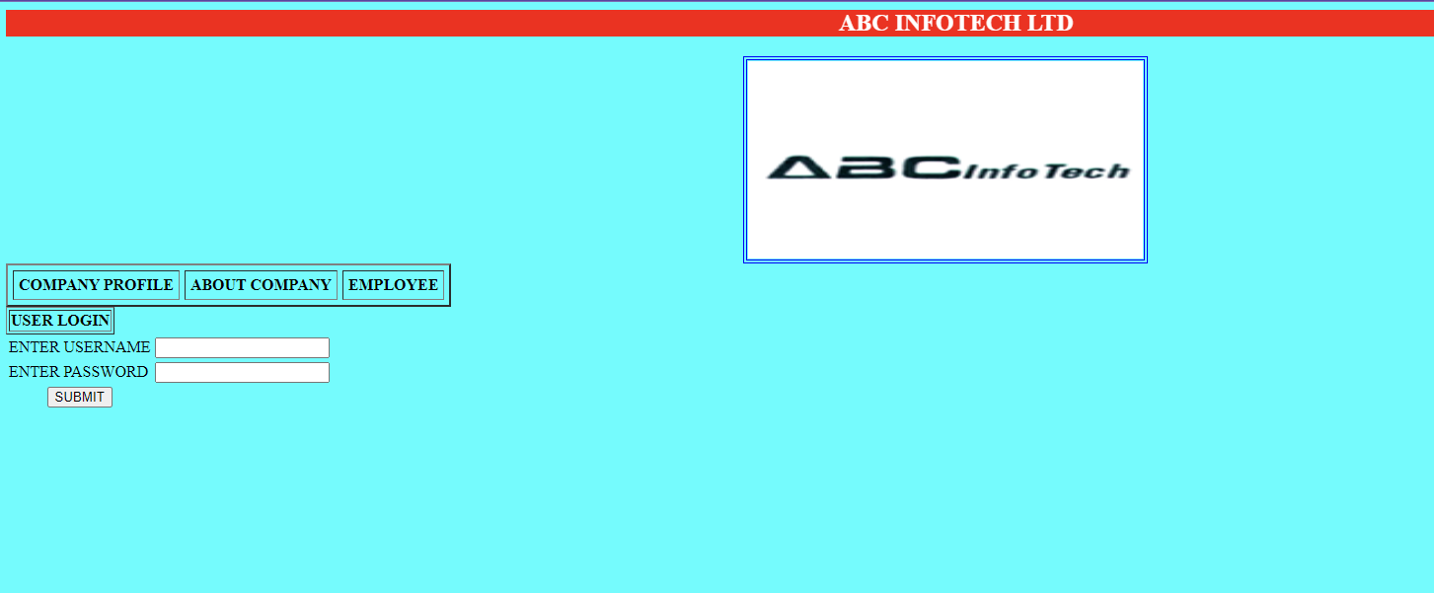

Result:
Successfully created a webpage for ABC InfoTech Company.

Ex No:2 .Create a Web pages which displays the menu card of a hotel,The first page should contain the list of items available.After selection of one item,the corresponding details should be displayed on next page
Date: 05.05.2024
Aim: To develop a webpage for display the menu card of a hotel.
CODE
<html>
<head>
<title>menu card</title>
<h1> <i><marquee bgcolor=orange>
hotel royal charlee</marquee></i></h1>
</head>
<body background="h:\fruit.gif">
<center><b><u><font color=0fff00 size=20 >menu card</u></b></center>
</font><ul><l1><a href="fast.html">breakfast</a><br>
<l1><a href ="meals.html">lunch</a><br>
<l1><a href="dinner.html">supper</a><br></ul>
</body>
</html>
BREAKFAST.HTML
<html>
<head>
<title>Break Fast</title>
</head><body bgcolor=ff00fd ><pre><h1>Break Fast</H1>
Items Price
Idly(2) 5.00
Vadai(1) 3.00
Pongal 7.00
Uthappam 8.00
Dosai 10.00
Poratta(2) 8.00
</pre><ul><l1><a href ="Meals.html">Lunch</a><br>
<l1><ahref="Dinner.html">Dinner</a><br></ul><a href="menu.html">Home</a>
</body></html>
LUNCH.HTML
<html>
<head><title>Dinner</title>
</head><body bgcolor=green><h1>Meals</h1>
<pre>
Items Price
Meals 25.00
SPl.Meals 30.00
</pre><ul><l1><a href="Fast.html">BreakFast</a><br>
<l1><a href="Dinner.html">Dinner</a><br></ul><br><br>
<a href="menu.html">Home</a>
</body>
</html>
SUPPER.HTML
<html><head><title>Dinner</title>
</head><body bgcolor=yellow><h1>Supper</h1>
<pre>
Items Price
Idly 5.00
Uthappam 8.00
Dosai 10.00
Barotta 8.00
</pre><ul><l1><a href="Fast.html">BreakFast</a><br>
<l1><a href ="Meals.html">Lunch</a></ul><br><a href="menu.html">Home</a>
</body>
</html>

OUTPUT
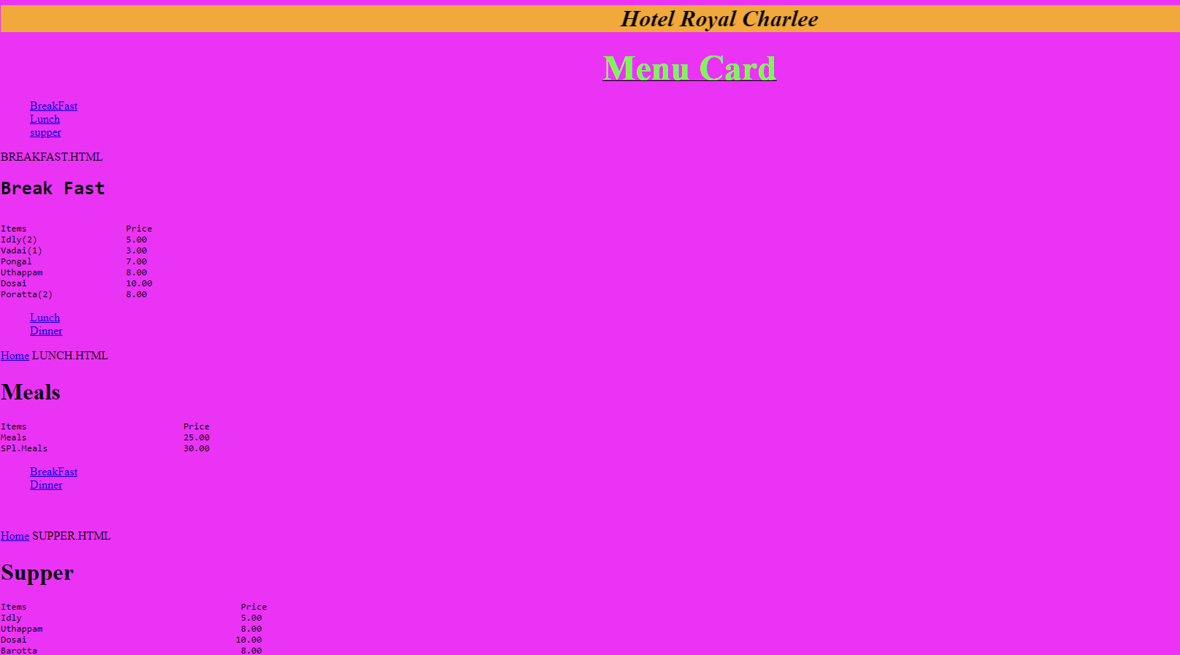
Result:
The above program is executed successfully and verified

Ex No: 3. Create a Web page which displays the balance sheets for the given list of companies.
Date: 12.05.2024
Aim: To develop a webpage for displays the balance sheets for the given list of companies
CODE
<HTML>
<TITLE>COMPANY BALANCE SHEET</TITLE>
<H1><I><center>COMPANY LIST</center></I></H1>
<BODY>
<LI> <A HREF="hclbal.HTML">HCL</A>
<LI> <A HREF="TVS.HTML">TVS</A>
<LI> <A HREF="ONIDA.HTML">ONIDA</A>
<LI> <A HREF="BPL.HTML">BPL</A>
</BODY>
</HTML>

Balance Sheet

<HTML>
<HEAD><TITLE>balance sheet</TITLE>
<META content="text/html; charset=windows-1252" http-equiv=Content-Type>
<META content="MSHTML 5.00.3502.5390" name=GENERATOR></HEAD>
<BODY>
<TABLE border=2 width="100%">
<CAPTION align=top>balance sheet of june 1999 </CAPTION>
<TBODY>
<TR>
<TH colSpan=5>liabilities</TH>
<TH colSpan=5>assets</TH>
<TR>
<TD></TD>
<TH>Rs</TH>
<TH>Ps</TH>
<TH>Rs</TH>
<TH>Ps</TH>
<TD></TD>
<TH>Rs</TH>
<TH>Ps</TH>
<TH>Rs</TH>
<TH>Ps</TH>
<TR>
<TD vAlign=top>
<P>share capital
<P>general reserve
<P><U>add:</U>transfer
<P>profit &amp; loss a/c (1)
<P>6% debenture
<P>bank loan
<P>future taxation
<P>current liabilities creditors
<P>proposed dividend free of tax </P></TD>
<TD vAlign=top><BR><BR>
<P align=right>3,000
<P align=right>5,000 </P></TD>
<TD vAlign=top><BR><BR>
<P align=right>00
<P align=right>00 </P></TD>
<TD vAlign=top>
<P align=right>50,000 <BR><BR><BR><BR>
<P align=right>8,000
<P align=right>18,000
<P align=right>50,000
<P align=right>20,000
<P align=right>5,000 <BR><BR>
<P align=right>22,000
<P align=right>3,000 <BR><BR> 4
<P align=right>4,000 <BR><BR></P></TD>
<TD vAlign=top
<P align=right>00 <BR><BR><BR><BR>
<P align=right>00
<P align=right>00
<P align=right>00
<P align=right>00
<P align=right>00
<P align=right>00
<P align=right>00
<P align=right>00 <BR><BR></P></TD>
<TD vAlign=top>
<P>freehold property
<P>plant &amp; machinery
<P>less depreciation <BR><BR>
<P>stock &amp; work in progress
<P>less:reduction in value
<P>debtors
<P>less:provision
<P>cash &amp; bank </P></TD>
<TD vAlign=top><BR><BR>
<P align=right>25,000
<P align=right>12,000
<P align=right>44,000
<P align=right>6,000
<P align=right>30,000
<P align=right>2,000 </P>
<TD vAlign=top><BR><BR>
<P align=right>00
<P align=right>00
<P align=right>00
<P align=right>00
<P align=right>00
<P align=right>00 </P>
<TD vAlign=top>
<P align=right>1,00,000 <BR><BR><BR><BR>
<P align=right>13,000 <BR><BR><BR><BR>
<P align=right>38,000 <BR><BR><BR><BR>
<P align=right>28,000
<P align=right>1,000 <BR><BR><BR><BR><BR><BR></P></TD>
<TD vAlign=top>
<P align=right>00 <BR><BR><BR><BR>
<P align=right>00 <BR><BR><BR><BR>
<P align=right>00 <BR><BR><BR><BR>
<P align=right>00
<P align=right>00 <BR><BR><BR><BR><BR><BR></P></TD>
<TR>
<TD>total</TD>
<TD></TD>
<TD></TD>
<TD align=right>1,80,000</TD>
<TD align=right>00</TD>
<TD>total</TD>
<TD></TD>
<TD></TD>
<TD align=right>1,80,000</TD>
<TD align=right>00</TD>
</TR>
</TBODY>
</TABLE>
</BODY>
</HTML>

OUTPUT
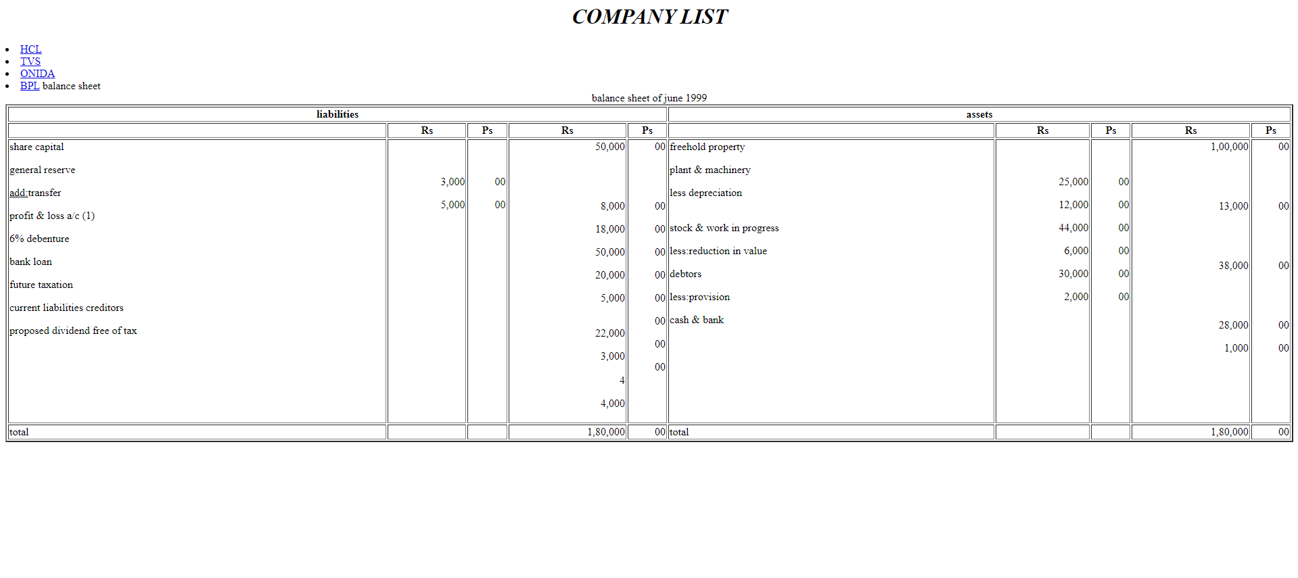

RESULT:
Successfully created a webpage balance sheets for the given list of companies

Ex No:4 . Create a Web page for XYZ INFOTECHT LTD,to display the company profile,employee details,balance sheet,receive resume,customer service using links.
Date: 12.05.2024
Aim :To develop a webpage for XYZ INFOTECH LTD .
CODE
<html>
<h2>xyz infotech ltd</h2>
<body>
<li><a href ="pro.html">profile</a>
<li><a href ="emp.html">employee</a>
<li><a href ="hclbal.html">balance sheet</a>
<li><a href ="res.html">resume</a>
<li><a href ="cus.html">customer service</a>
</body>
</html>
PRO.HTML

<html>
<head>
<title>COMPANY PROFILE</title>
</head>
<body bgcolor=cyan>
<center>
<h1><u>XYZ INFOTECH COMPANY PROFILE</u></h1>
<br>
<table border=1>
<tr>
<th>ABOUT COMPANY</th>
<th>COMPANY DETAIL</th>
</tr>
<tr>
<td><b>COMPANY NAME</b></td>
<td><center>XYZ INFOTECH </center></td>
</tr>
<tr>
<td><b>COMPANY BRANCHES</b></td>
<td><ul type="square">
<li>TRICHY
<li>BANGALORE
<li>HYDERABAD
<li>KOCHIN
<li>KOLKATTA
</ul></td>
</tr>
<tr><td><b>COMPANY DEPARTMENTS </b></td>
<td><ul type="circle">
<li>Human Resource Department
<li>Accounts Department
<li>project division
<li>Technical Department
<li>Non Technical Department
</ul>
</td>
</tr>
<td><b>ACHIVEMENTS</b></td>
<td><ul type=circle>
<li>Business Level Toppers
<li>Spontaneous project developers
</ul>
</td>
</tr></table>
</body></html>
RES.HTML

<html>
<h2>xyz infotech ltd </h2>
<table><br>
<tr><td>name</td>
<td><input type=textbox name="name" size=12</td>
<tr><td>father name</td>
<td><input type=textbox name="fathername" size=12></td>
<tr><td>date of birth</td>
<td><input type=textbox name="dob" size=8></td>
<tr><td>age</td>
<td><input type=textbox name="age" size=8></td>
<tr><td>sex</td>
<td>male</td>
<td><input type=radio name="one"></td>
<td>female</td>
<td><input type=radio name="one"></td>
</table></html>

OUTPUT

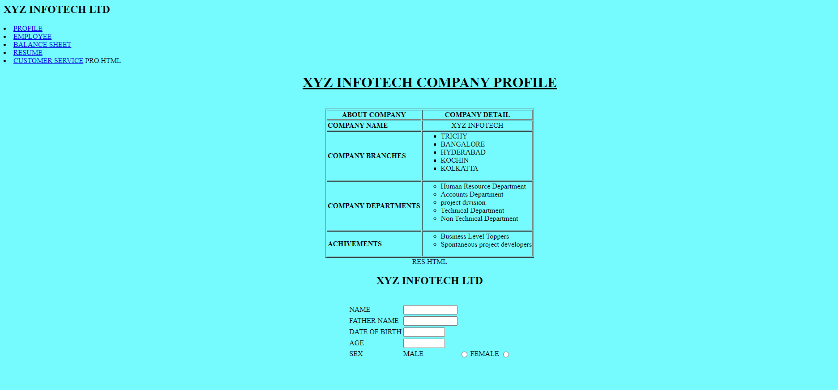

RESULT:
Successfully created a webpage and display the company profile,employee details,balance sheet,receive resume,customer service using links.

Ex No: 5 .Using Frames create web pages for travel agencies.
Date: 19.05.2024
Aim: To develop a webpage for travel agencies

CODE
<html><title>frames</title>
<frame>
<frameset rows="25%,65%">
<frame src="tra.html">
<frame src="tra1.html" name="det">
</frameset>
</frame>
</html>

TRA.HTML
<HTML><body background="H:/1.jpg.jpg"><H2>JAI HUNUMAN TRAVEL AGENCI<H2>
<H4>Reg Govt.of India Tourism</h4>
</body>
</html>

TRA1.HTML
<html><body bgcolor="#6456328"><center>
North Indian tour and Kasiyatra
<table border cellpadding=10 cellspacing=10>
<tr><th>delhi to agra</th>
<th>06.07.06</th><th>6700.00 Rs</th>
<tr><th>Jaipur to amirtsar and Kasi</th>
<th>14.08.06</th><th>5000.00 Rs</th>
<tr><th>Kolkatta to kasi</th>
<th>10.09.06</th><th>4500.00 Rs</th>
<tr><th>All India and Kasi</th>
<th>17.09.06</th><th>9500.00 Rs</th>
</table></center>
</body>
</th>
OUTPUT
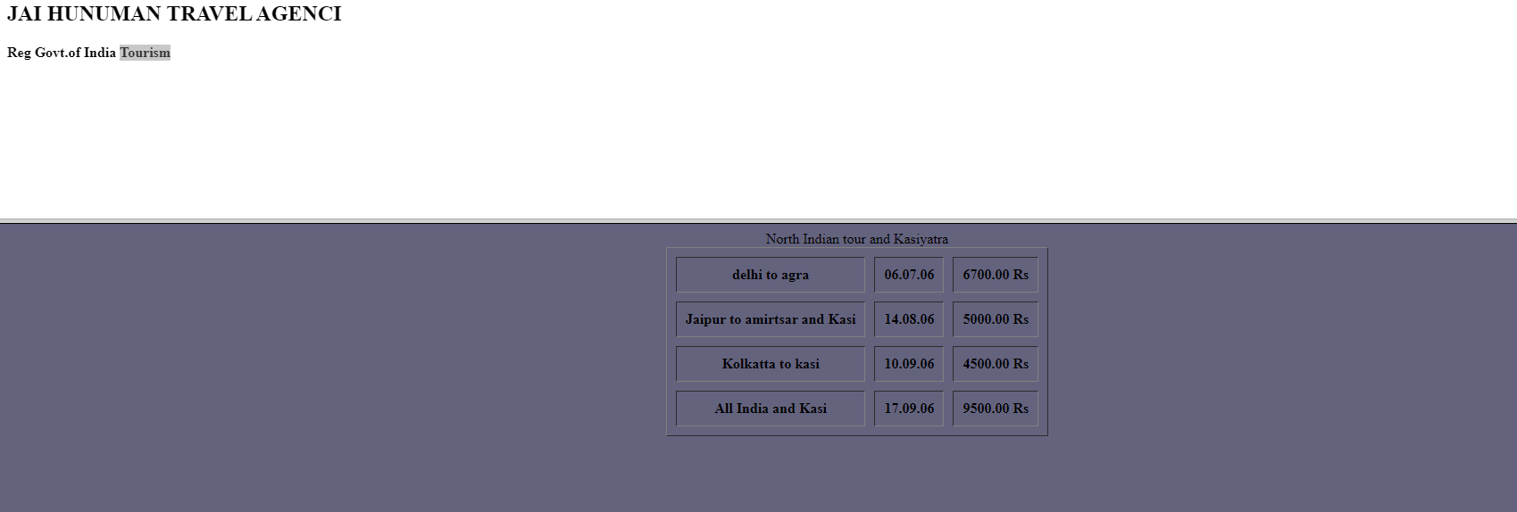

RESULT:
Successfully created a web for travel agencies.

Ex No:6 . Create a Web page using forms for our College Students admission process.
Date: 19.05.2024
Aim: To develop a webpage for college students admission .
CODE
<html>
<center>
<head>Admission Form</head>
<table>
<tr><td>Name:</td>
<td><input type="Text box" Name="name" size=12></td>
<tr><td>Fathers Name:</td>
<td><input type="Text box" Name="name" size=12></td>
<tr><td>Date of Birth</td>
<td><input type="Text box" Name="age" size=12></td>
<tr><td>sex:</td>
<tr><td>Female</td>
<td><input type="radio" Name="one"></td>
<tr><td>male</td>
<td><input type="radio" name="one"></td>
<tr><td>UG COURSES:</td>
<td><input type="Text Area" Name="Courses" size=20></td></tr>
<tr><td><select name="UGCOURSES">
<option>1.Bcom<br>
<option>2.BscIT<br>
<option>3.B.B.A<br></td></tr>
</select>
<tr><td>PG COURSES</td>
<td><input type="Text Area" name="courses" size=20></td></tr>
<tr><td><select name="PGCOURSES">
<option>1.Mcom<br>
<option>2.MscIT<br>
<option>3.MBA<br></td></tr>
</select>
<tr><td><input type="SUBMIT" value="OK"></td>
<td><input type="Reset" value="Reset"></td></tr>
</option>
</center>
</html>

OUTPUT
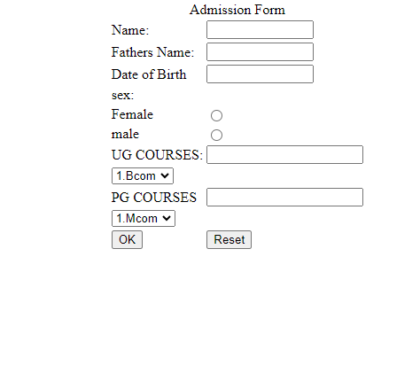

RESULT:
Successfully created a webpage for student’s admission.

Ex No:7 Write a program to display multiplication table in webpage.
Date: 26.05.2024
Aim: To develop a webpage for displaying multiplication table in webpage .
CODE
<html>
<body>
<!--Multiplication table in javascript-->
<h1>Multiplication Table</h1>
Enter a number:
<input type="text" id="num" /><br /><br />
<input type="button" value="create" onClick="multiply()" />
<p id="result"></p>
<script>
function multiply() {
var n = document.getElementById('num').value;
var l = "11";
var out = "";
for (var i = 1; i < l; i++) {
out = out + i + " * " + n + " = " + i * n + "<br/>";
}
document.getElementById("result").innerHTML = out;
}
</script>
</body>
</html>

OUTPUT

RESULT:
Successfully display the multiplication table in webpage.

Ex No:8 Create a webpage which displays the mouse co-ordinates and image co-ordinates.
Date: 26.05.2024
Aim: To develop a webpage for displays the mouse co-ordinates and image co-ordinates.
CODE
<html>
<head>
<title>Mouse and Image Co-ordinates</title>
<style>
body {
font-family: Arial, sans-serif;
background-color: #f2f2f2;
}
#container {
width: 800px;
margin: 0 auto;
text-align: center;
}
#image {
width: 200px;
margin: 20px auto;
}
#coordinates {
font-size: 20px;
margin-bottom: 20px;
}
</style>
</head>
<body>
<script>
function getMouseCoordinates(event) {
var x = event.clientX;
var y = event.clientY;
document.getElementById("mouse-coordinates").innerHTML = "Mouse Co-ordinates: " + x + ", " + y;
}
function getImageCoordinates(event) {
var x = event.offsetX;
var y = event.offsetY;
document.getElementById("image-coordinates").innerHTML = "Image Co-ordinates: " + x + ", " + y;
}
</script>
<div id="container">
<h1>Mouse and Image Co-ordinates</h1>
<img id="image" src="image.jpeg" alt="Image">
<div id="coordinates">
<p id="mouse-coordinates"></p>
<p id="image-coordinates"></p>
</div>
</div>
<script>
var image = document.getElementById("image");
image.addEventListener("mousemove", getMouseCoordinates);
image.addEventListener("click", getImageCoordinates);
</script></body>
</html>

OUTPUT:

RESULT:
Successfully displays the mouse co-ordinates and image co-ordinates in webpage.

